RE: ORGANIZATIONAL MEMBERSHIP to GREEN PARTY OF THE PHILIPPINES (GPP-KALIKASAN MUNA).

Isang Makakalikasang Pagbati!

In the name of the Interim National Council of the Green Party of the Philippines, I would like to invite your organization to be a member of the Green Party of the Philippines (GPP – KALIKASAN MUNA).

As National President of GPP and adviser of KALIKAS, I am inviting organizations to join the movement and advocate for the Green Agenda in order to make a long term change in our country. As a member your organization and its members will:

- Be part of its activities and programs.
- Chance to be elected in local, provincial, regional and national party leadership.
- Have an automatic representation in the local, provincial, regional and national council, were your organization membership is active and present.
- Help form the strategy and network structure of the organization.

Major requirement is for your organization to adopt and subscribe to the GREEN AGENDA as follows:

- Climate emergency actions
- Organic, safe food & food security
- Biodiversity conservation in sustainable habitats
- Sustainable forest cover
- A swift shift to renewable energy
- Ecological solid waste mgmt & pollution control
- Greening human settlements
- A national moratorium on mineral mining
- Sustainable development by green governance
- Full protection of “peoples” for self-determination towards sustainable development

The full text of the above GREEN AGENDA can be viewed at https://www.greenparty.ph/the-green-agenda/.

We hope that you will be part of the organizational membership of the movement to create a long-term solution for the environmental problems of our country.

If you are in agreement please sign the Memorandum of Agreement attached to this letter.
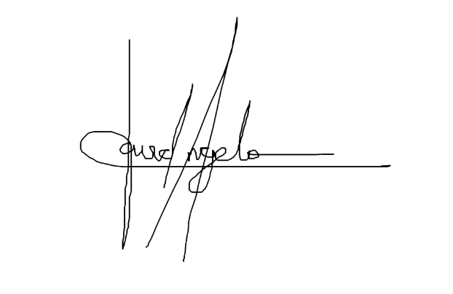

Sincerely yours,

David D’Angelo
National President
Green Party of the Philippines

MEMORANDUN OF AGREEMENT

This Memorandum of Agreement is between GREEN PARTY OF THE PHILIPPINES (GPP – KALIKASAN MUNA) and .

The agreement are as follows:

agree to the following:

- That they will become a member of the Green Party of the Philippines (GPP-KALIKASAN MUNA).
- They will participate in the strategizing, networking and expansion of the organization.
- They agree to support the 10-POINT GREEN AGENDA as follows:
  - Climate emergency actions
  - Organic, safe food & food security
  - Biodiversity conservation in sustainable habitats
  - Sustainable forest cover
  - A swift shift to renewable energy
  - Ecological solid waste mgmt & pollution control
  - Greening human settlements
  - A national moratorium on mineral mining
  - Sustainable development by green governance
  - Full protection of “peoples” for self-determination towards sustainable development
- Provide a list of members which contains name of members, contact number and location.

Green Party of the Philippines (GPP-KALIKASAN MUNA) agrees to the following:

- Provide a seat in the National Executive Council of KALIKAS to the organization, as long as their membership is more than 100.
- Allow participation of the organization in GPP-KALIKASAN MUNA activities.
- Allow members to apply for GPP-KALIKASAN MUNApositions..
- Allow members to participate in GPP-KALIKASAN MUNA activities.
- Support its activities.
- Allow automatic representation in the local, provincial, regional and national council, were your organization membership is active and present.

Both parties sign this agreement knowing that only lawful activities will be conducted.

FOR GPP-KALIKASAN MUNA FOR
_____________________________

Name : David D’Angelo _____________________________
Designation : National President _____________________________
Signature: : _____________________________
Date : _____________________________

